**SHRI RAMDEOBABA COLLEGE OF ENGINEERING AND MANAGEMENT NAGPUR**

A

MINI

PROJECT ON

“Student Management System”

SUBMITTED BY

40 Karan Harode 41Nandan Partani

70 Gaurav Singh 71 Prasanna Tangade

72 Vishal Bhutada

MENTOR

Prof. Neha Tirpude

Department of Cyber Security

# INDEX

1. Chapter 1 :- Title of Mini Project ……..01-01
2. Chapter 2:- Group Member Details .01-01
3. Chapter 3:- Problem Statement ...03-03
4. Chapter 4 :- Dataset Details 04-04
5. Chapter 5:- Expected Outcome…………………….......05-05
6. Chapter 6:- Output Snapshots………………………….06-07

# Chapter 3:

# Problem Statement:

# The problem occurred before having computerized system includes: File lost

# When computerized System is not implemented file is always lost because of

# human environment due to some human Error there may be a loss of records, file

# damaged when a computerized system is not there file is always lost due to some

# accident like of water by some member on file accidentally. Besides some natural

# disaster like floods or fires may also damage the files. Difficult to search record

# When there is no computerized system there is always a difficulty in searching

# of records if the records are large in number, space consuming, After the number

# of records become large the space for physical storage of file and records also if

# no computerized system is implemented. Cost consuming as there is no

# computerized system to add each record paper will be needed which will increase

# the cost the management of library.

# Chapter 4:

# Details of Dataset:

# This is a simple console based system which is very easy to understand and use. Talking about the system, it contains basic functions which include Add students, view students, search students and remove the student. In this mini project, there is no such login system. This means he/she can use all those available features easily without any restriction. It is too easy to use, he/she can check the total student’s record.

# The project file contains a student.csv file to save data that is added by the user. It automatically updated when we add or remove data.

# Dataset row header contain Roll No, Name, Age and Mobile Number.

**Chapter 5:**

**Expected Outcome:**

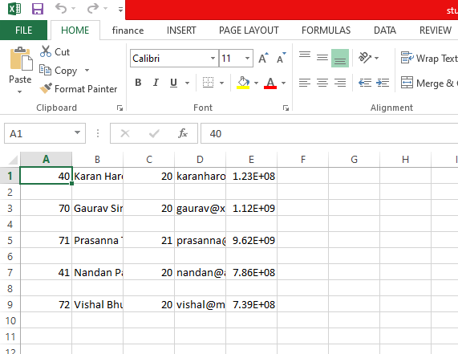

**Chapter 6:**

**Output Snapshots:**



 